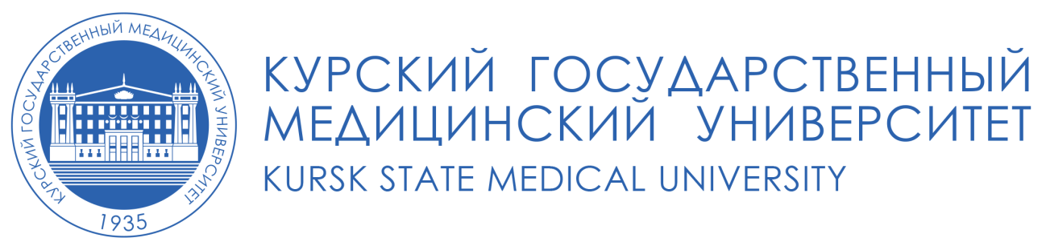
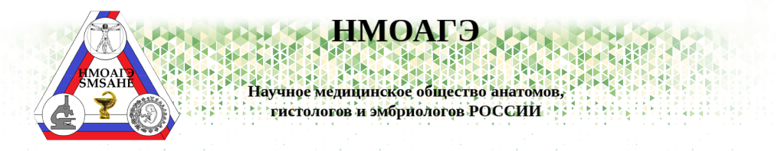
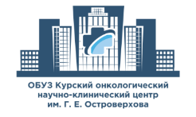
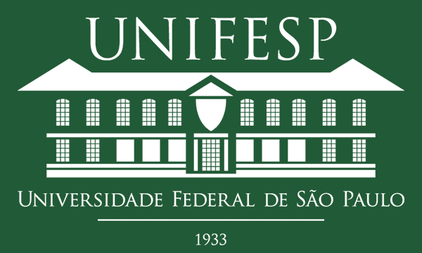

FSBEI HE Kursk State Medical University
of the Ministry of Health of the Russian Federation
Scientific Medical Society of Anatomists, Histologists and Embryologists of Russia,
Kursk section of SMS AHE
Kursk Oncology Research and Clinical Center named after G.E. Ostroverkhov (Kursk, Russia)
Regional Budgetary Healthcare Institution Forensic Medical Examination Bureau of the Kursk Region Healthcare Committee (Kursk, Russia)
Gomel State Medical University (Republic of Belarus)
Federal University of São Paulo-UIFESP Paulista School of Medicine (São Paulo, Brazil)
Beirut Arab University (Beirut, Lebanon)
Charisma University School of Health Sciences (Turks & Caicos Islands)
Jinzhou Medical University College of International Education (Jinzhou, Liaoning, China)
Federal State Budgetary Educational Institution of Higher Education Kazan State Medical University of the Ministry of Health of the Russian Federation
Federal State Budgetary Educational Institution of Higher Education Krasnoyarsk State Medical University of the Ministry of Health of the Russian Federation
State Institution of Lugansk People's Republic Lugansk State Medical University named after Saint Luke
Medical Institute of Federal State Budgetary Educational Institution of Higher Education Oryol State University named after I.S. Turgenev

Highly respected colleagues!
We invite you to take part in the international scientific and methodological conference "Modern Aspects of Morphology, Pathomorphology and Oncopathology of the Human Body", which will be held on March 24-25, 2023 in Kursk
Conference organizers:
Federal State Budgetary Educational Institution of Higher Education Kursk State Medical University of the Ministry of Health of the Russian Federation
Scientific Medical Society of Anatomists, Histologists and Embryologists of Russia, Kursk section of SMS AHE
Kursk Oncology Research and Clinical Center named after G.E. Ostroverkhov (Kursk, Russia)
Regional Budgetary Healthcare Institution Forensic Medical Examination Bureau of the Kursk Region Healthcare Committee (Kursk, Russia)
Gomel State Medical University (Republic of Belarus)
Federal University of São Paulo-UIFESP Paulista School of Medicine (São Paulo, Brazil)
Beirut Arab University (Beirut, Lebanon)
Charisma University School of Health Sciences (Turks & Caicos Islands)
Jinzhou Medical University College of International Education (Jinzhou, Liaoning, China)
Federal State Budgetary Educational Institution of Higher Education Kazan State Medical University of the Ministry of Health of the Russian Federation
Federal State Budgetary Educational Institution of Higher Education Krasnoyarsk State Medical University of the Ministry of Health of the Russian Federation
State Institution of Lugansk People's Republic Lugansk State Medical University named after Saint Luke
Medical Institute of Federal State Budgetary Educational Institution of Higher Education Oryol State University named after I.S. Turgenev
Topics of the conference:
1. Anthroponutritiology and age aspects of human body morphology.
2. Issues of tissue regeneration after exposure to factors of different etiology.
3. Modern ideas on pathomorphological diagnosis of human diseases.
4. Achievements in morphological diagnosis of oncopathology.
5. Issues of forensic medicine
6.Topical issues of teaching morphological disciplines in conditions of hybrid learning (intramural studies and distance learning).

Conference format: hybrid format (in person and online participation via videoconferencing, publication of the conference materials).
Official languages of the conference: Russian, English.

Participation in the conference is free of charge.

The conference materials will be published in the collection of scientific papers and registered in the scientific electronic library E-library and RSCI. The DOI index will be assigned article by article. For participation in the conference, it is necessary to send an application for participation, pointing out the form of participation, and an article to morphksmu85@yandex.ru (with "Conference" in the subject line) before March 10, 2022, two files in the *.doc format in a single package. All received materials will be checked in the Antiplagiat system and double-blind peer reviewed.

- Each participant of the conference should fill in an application
for participation in the conference in Russian or English (Citizens of the Russian Federation and CIS countries complete the application in Russian, citizens of other countries – in English).
The name of the file with the application must include the full name of the participant, country, city and the form of participation (online or in person) without spaces, separated by the underscore.
Example: ПетровИА_Россия_Москва_ВКС.doc or Smith_Brazilia_SanPaolo_online.doc.

Conference participant
Full name
Form of participation (online, in person)
Form of the report (in person, poster, poster presentation, remote, no report)
Full name of the place of work (study)
Abbreviated name of the place of work (study)
Postal address of the place of work
Department, position (for the employed) / faculty, year of study (for students)
Academic degree (if any)
Academic title (if any)
E-mail address for communication
Phone number (WhatsApp, Viber, Telegram)
Consent to personal data processing (indicate YES or NO)

We kindly ask the speakers who plan to present their reports via videoconferencing to send the video file of the report to the conference e-mail address beforehand.
II. Application for publication of the materials
An article may be written in Russian or English with a total volume of at least 5 pages in A-4 format. The name of the file with the article must include the full name of the first participant/author, country, city and type of the file (without spaces, separated by the underscore).
Example: ПетровИА_Россия_Москва_статья.doc or Smith_Brazilia_SanPaolo_art.doc
One author may submit not more than 3 articles. The article may contain tables, figures and diagrams (black and white only, easily readable). The text should be typed in the MS WORD editor, Arial font, font size - 14 pt, line spacing - 1.5; page margins - 2 cm on all sides. Text alignment – full justification. The first line indent is 1.25 cm. No page numbering.

Article submission requirements:

- Surname and initials of the author (center justification, Arial font, font size - 14 pt)
- Article heading (center justification, in block letters, Arial font, font size - 14 pt)
- Institution (name, city, country, center justification, Arial font, font size - 14 pt)
Empty line
- Volume of the abstract should be 250 - 300 words and must fully reflect the content and structure of the article (Text alignment – full justification, Arial font, font size - 14 pt). It should have the form of a text with the following subheadings: introduction (timeliness), purpose, materials and methods, results, conclusion.
- Keywords: up to 5 words (Text alignment – full justification, Arial font, font size - 14 pt)
Empty line
- The text of a scientific article (Text alignment – full justification, Arial font, font size - 14 pt) consists of the following sections: introduction, purpose, materials and methods, results and their discussion, findings or conclusion. It is allowed to add diagrams, tables, figures and photographs with obligatory references to the illustrative material in parentheses in the text (Example: fig.1, table 1).
- References to the cited literature (up to 20 references are allowed) should be listed alphabetically. References in the text of the article must be placed in the square brackets at the end of the sentence. We kindly ask You to avoid self citation.
- Information about the authors.
- Information about the conditions of financing of Your studies, if it was carried out with third-party funding (for example, grant support), and absence of conflict of interest.

If You have any questions, contact morphksmu85@yandex.ru or call:
- Head of the Department of Histology, Cytology and Embryology, Doctor of Medical Sciences, Professor Alexander Viktorovich Ivanov, phone number: +79103100310
- Professor of the Department of Human Anatomy, Doctor of Medical Sciences Irina Nikolaevna Yashina, phone number: +79102109730
- Head of the Department of Pathological Anatomy, Candidate of Medical Sciences, Associate Professor Viktor Tarasovich Dudka, phone number: +79103149855
- Head of the Department of Oncology, Candidate of Medical Sciences, Associate Professor Khvostovoy Vladimir Vladimirovich, phone number: +79103180432
- Head of the Department of Forensic Medicine, Doctor of Medical Sciences, Professor Tenkov Alexander Afanasievich, phone number: +79202605347

We look forward to welcoming you to the hospitable Kursk land.

